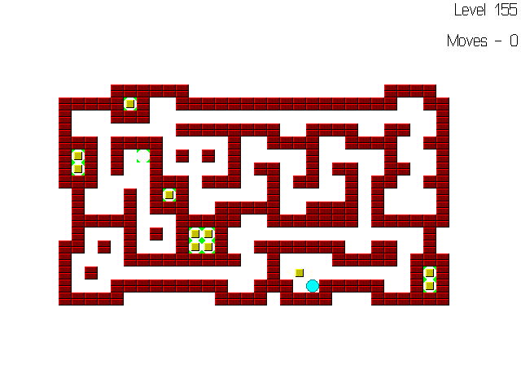

**2011-2012**

Joel M. Pinto

C++ Project

XII-Sci

Roll No.:

Sokoban

Index

|  |  |  |  |
| --- | --- | --- | --- |
| **S.No.** | **Name** | **Description** | **Pg. No.** |
| 1 | Acknowledgements | Credits to our benefactors | 3 |
| 2 | Sokoban.cpp | Contains main() | 4 |
| 3 | Map.cpp | Handles navigation in a level | 6 |
| 4 | Image.cpp | Handles sprites (images) | 11 |
| 5 | ImageLdr.cpp | Image Loader; Handles loading sprites for cells | 13 |
| 6 | KeyBrd.cpp | Encapsulates Keyboard input | 14 |
| 7 | LevelSys.cpp | Level System; Handles loading levels | 15 |
| 8 | GameEng.cpp | The game engine for Sokoban | 18 |
| 9 | MainMenu.cpp | Main Menu for the game | 20 |
| 10 | Screenshots | Screen captures of the game | 25 |

Acknowledgements

First and foremost, we would like to express our gratitude towards Principal Sir, **Mr. Joy Thaliyachira K.** for providing us this opportunity to learn programming in practice. We are also grateful to the school for the computer lab infrastructure.

We are extremely indebted towards our talented Computer Science Instructor, **Mr. Eroz T. Awari** for his guidance, effort, patience, and attention to every minute detail in teaching us effective programming skills.

We would like to give credit to all the testers of the code including Vishesh Sanghvi, Keyur Patel, Michael Pinto and Jennifer Pinto. They have also given suggestions for the improvement of the project. We also thank David W. Skinner for letting us use his Microban level pack (155 levels) in our project.

Sokoban.cpp

/***************************************************************************\

Project name: Sokoban

Release version: 1.0

Programmers: Nishit Vashi, Jatin Patel, Joel M. Pinto

Created: 09-10-2011 06:42 pm

Completed: 26-12-2011 11:33 pm

About:

This C++ project aims to replicate the popular classic puzzle

game Sokoban.

[From Wikipedia - http://en.wikipedia.org/wiki/Sokoban]

Sokoban is a type of transport puzzle, in which the player

pushes boxes or crates around in a warehouse, trying to get

them to storage locations. Sokoban was created in 1981 by

Hiroyuki Imabayashi, and published in 1982 by Thinking Rabbit, a

Software house based in Takarazuka, Japan.

Rules:

1. Only one box can be pushed at a time.

2. A box cannot be pulled.

3. The player cannot walk through boxes or walls.

4. The puzzle is solved when all boxes are located at storage

locations.

Program files:

Sokoban.cpp - Contains main()

Map.cpp - Handles navigation in a level

Image.cpp - Handles sprites (images)

ImageLdr.cpp- Image Loader; Handles loading sprites for cells

Keybrd.cpp - Encapsulates Keyboard input

LevelSys.cpp- Level System; Handles loading levels

GameEng.cpp - The game engine for Sokoban

MainMenu.cpp- Main Menu for the game

\***************************************************************************/

//Include libraries

#include<iostream.h>

#include<conio.h>

#include<graphics.h>

//Include code files

#include "C:\SOKOBAN\mainmenu.cpp"

#include "C:\SOKOBAN\gameeng.cpp"

//Main body of program

int main()

{

//Initialize graphics mode

int gdriver=DETECT, gmode;

initgraph(&gdriver, &gmode, "..\\BGI");

int errorcode=graphresult();

if (errorcode!=grOk)

{

cout<<"Could not load graphics mode\n\n"

<<"Error Description: "<<grapherrormsg(errorcode)

<<"\nExiting...";

getch();

return 1;

}

//Show the Main Menu

while(1)

{

switch(Main_Menu::show()) //Check the user's choice

{

case 1: //Play

Game_Engine ge;

ge.start();

break;

case 2: //About

Main_Menu::display_about();

break;

case 3: //Help

Main_Menu::display_help();

break;

case 4: //Tutorials

Game_Engine tut("C:\\sokoban\\levels\\tut",5);

tut.start();

break;

case 5: //Exit

//Show a confirmation dialog

if (!Main_Menu::confirm_exit()) break;

closegraph(); //Go back to text mode

return 0;

}

}

}

Map.cpp

/*

Map.cpp - Handles navigation in a level

Part of the Sokoban project

(See Sokoban.cpp for details)

*/

// The following if condition prevents accidental

// double inclusion in other files.

#ifndef MAP_CPP

#define MAP_CPP

#include<fstream.h>

#include<stdio.h>

#include "C:\SOKOBAN\imageldr.cpp"

//map data - possible cell values

const int c_empty=0;

const int c_wall=1;

const int c_box=2;

const int c_target=4;

const int c_player=8;

//Map class and function declarations

class Map

{

private:

int r; //no. of rows in the cell grid

int c; //no. of columns in the cell grid

int grid[30][40]; //max 30 rows by 40 columns - stores the grid data

int plrx; //x-coordinate of player position

int plry; //y-coordinate of player position

int no_of_moves;

void move_plr_to(int, int, int); //Move player to position (x,y)

public:

int get_cell(int, int); //Accessor for cell type at (x,y)

void set_cell(int, int, int); //Sets the cell type at (x,y) with 'cell'

Map(); //Constructor

int load_from_file(char *); //Loads the current instance from a file

int save_to_file(char *); //Saves the current instance to a file

int num_rows() //Accessor for number of rows

{

return r;

}

int num_cols() //Accessor for number of columns

{

return c;

}

void num_rows(int _r) //Mutator for number of rows

{

if (_r>=0&&_r<=30)

r=_r;

}

void num_cols(int _c) //Accessor for number of columns

{

if (_c>=0&&_c<=40)

c=_c;

}

int player_x() //Accessor for player position (x)

{

return plrx;

}

int player_y() //Accessor for player position (y)

{

return plry;

}

void player_x(int x) //Mutator for player position (x)

{

if(x>0&&x<c)

plrx=x;

}

void player_y(int y) //Mutator for player position (y)

{

if(y>0&&y<r)

plry=y;

}

int num_moves() //Accessor for number of moves

{

return no_of_moves;

}

void try_move(char, int, int =1);

//Try to move player on 'axis' by 'offset' cells

//Also call show_num_moves() if show_moves!=0

int check_win(); //Check if the level has been completed

void update_image(int, int); //Updates the image of the cell at (x,y)

void show_num_moves();

};

//function definitions

//Constructor

Map::Map()

{

//Initialize everything with valid data

r=30;

c=40;

for(int i=0;i<30;++i)

for(int j=0;j<40;++j)

grid[i][j]=0;

plrx=plry=0;

no_of_moves=0;

}

//Accessor for cell type at (x,y)

int Map::get_cell(int x, int y)

{

return grid[y][x]; //Row=y, Column=x

}

//Sets the cell type at (x,y) with 'cell'

void Map::set_cell(int x, int y, int cell)

{

if (x<0||x>=c || y<0||y>=r)

return; //Cell coordinates out of range, so reject

if (cell>=0&&cell<=12) //12 is max possible cell value

grid[y][x]=cell;

}

//Loads the current instance from a file. Returns 1 if error encountered.

int Map::load_from_file(char *path)

{

ifstream level;

level.open(path,ios::in,ios::binary);

if (!level) return 1; //Error in file opening

if(!level.read((char *)this,sizeof(Map))) //Store in current instance

{

level.close();

return 1; //Error while reading

}

level.close();

for(int x=0;x<c;++x)

for(int y=0;y<r;++y)

update_image(x,y);

return 0;

}

//Saves the current instance to a file. Returns 1 if error encountered.

int Map::save_to_file(char *path)

{

ofstream level;

level.open(path,ios::out,ios::binary);

if (!level) return 1; //Error in file creation

//level.seekp(0,ios::beg);

level.write((char *)this,sizeof(Map)); //Write the current instance

level.close();

return 0;

}

//Try to move player on 'axis' by 'offset' cells

void Map::try_move(char axis, int offset, int showmoves)

{

//adj1 = 1st adjacent cell in the direction the player wants to move

//adj2 = cell adjacent to 1st adjacent cell

int adj1_x,adj1_y,adj2_x,adj2_y; //cell position coordinates

int adj1_cell,adj2_cell; //cell types

if(axis=='x'||axis=='X')

{

adj1_x=plrx+offset;

adj1_y=plry;

adj2_x=adj1_x+offset;

adj2_y=adj1_y;

}

else if(axis=='y'||axis=='Y')

{

adj1_x=plrx;

adj1_y=plry+offset;

adj2_x=adj1_x;

adj2_y=adj1_y+offset;

}

adj1_cell=get_cell(adj1_x,adj1_y);

if (adj1_cell==c_empty||adj1_cell==c_target)

move_plr_to(adj1_x,adj1_y,showmoves);

else if (adj1_cell==c_wall)

return ; //cannot push wall

else if (adj1_cell&c_box) //cell has box (with or without target)

{

adj2_cell=get_cell(adj2_x,adj2_y);

if(adj2_cell&c_wall || adj2_cell&c_box)

return ;

//cannot push coz box is against a wall or another box

else //Box is pushable

{

//Add box to adj2

set_cell(adj2_x,adj2_y,adj2_cell|c_box);

update_image(adj2_x,adj2_y);

//Remove box from adj1

set_cell(adj1_x,adj1_y,adj1_cell&(~c_box));

//Move player to adj1

move_plr_to(adj1_x,adj1_y,showmoves);

}

}

}

//Move player to position (x,y)

//if showmoves!=0, number of moves will be shown

void Map::move_plr_to(int x, int y, int showmoves)

{

//Remove player from old cell (plrx,plry)

int playercell=get_cell(plrx,plry);

set_cell(plrx,plry,(playercell&(~c_player)));

update_image(plrx,plry);

//Send player to new cell (x,y)

playercell=get_cell(x,y);

set_cell(x,y,(playercell|c_player));

update_image(x,y);

plrx=x;

plry=y;

no_of_moves++;

if(showmoves)

show_num_moves();

}

//Shows the number of moves on the screen

void Map::show_num_moves()

{

char strmoves[20]="";

sprintf(strmoves,"Moves - %d",no_of_moves);

//erase old label

setfillstyle(SOLID_FILL,WHITE);

bar(640,textheight("Level")+20,640-textwidth("Moves - XXX"),

2*textheight("Level")+20);

//display new label

settextjustify(RIGHT_TEXT,TOP_TEXT);

outtextxy(640,textheight("Level")+20,strmoves);

}

//Check if the level has been completed

int Map::check_win()

{

for(int i=0;i<r;++i)

for(int j=0;j<c;++j)

if(get_cell(j,i)&c_target)

if((get_cell(j,i)&c_box)==0)

return 0;

return 1;

}

//Updates the image of the cell at (x,y)

void Map::update_image(int x, int y)

{

int mapx=320-(c*SPR_WIDTH)/2;

int mapy=240-(r*SPR_HEIGHT)/2;

int cellx=mapx+x*SPR_WIDTH;

int celly=mapy+y*SPR_HEIGHT;

int c=get_cell(x,y);

if(c==c_empty)

{

il.Empty.display(cellx,celly,-1);

return ;

}

if(c==c_wall)

{

il.Wall.display(cellx,celly,WHITE);

return ;

}

if(c&c_target)

{

if (c==c_target)

il.Target.display(cellx,celly,-1);

else

il.Target.display(cellx,celly,WHITE);

}

if(c&c_box)

{

il.Box.display(cellx,celly,WHITE);

return ;

}

if(c&c_player)

{

il.Player.display(cellx,celly,WHITE);

}

}

#endif //MAP_CPP

Image.cpp

/*

Image.cpp - Handles sprites (images)

Part of the Sokoban project

(See Sokoban.cpp for details)

*/

// The following if condition prevents accidental

// double inclusion in other files.

#ifndef IMAGE_CPP

#define IMAGE_CPP

#define SPR_HEIGHT 16 //Max height of sprites

#define SPR_WIDTH 16 //Max width of sprites

#include<graphics.h>

#include<fstream.h>

class Image

{

private:

unsigned char _pixdat[SPR_HEIGHT][SPR_WIDTH]; //pixel data

public:

void display(int, int, int);

int load_from_file(char *); //file must be .raw file type

};

//Loads the current instance from a file. Returns 1 if error encountered.

int Image::load_from_file(char *path)

{

ifstream imgfile;

imgfile.open(path,ios::in|ios::binary);

if (!imgfile) return 1; //Error in file opening

unsigned char dat;

for(int i=0;i<SPR_HEIGHT;++i)

for(int j=0;j<SPR_WIDTH;++j)

{

//Read each byte(char) from the file

imgfile.read((char *)&dat,sizeof(char));

//Each byte in the RAW 4bpp format used by

//Photoshop is 0000KBGR (K=brightness).

//It should be converted to 0000KRGB, so

//swap bit 0 with bit 2 i.e, red and blue

dat=((dat&0x01)<<2)|((dat&0x04)>>2)|(dat&0x0A);

//0x0A = (bin)00001010

//0111 has to be interchanged with 1000 for correct color

if (dat==7) dat=8;

else if (dat==8) dat=7;

_pixdat[i][j]=dat;

}

imgfile.close();

return 0;

}

void Image::display(int x, int y, int transparency_key)

{

for(int i=0;i<SPR_HEIGHT;++i)

for(int j=0;j<SPR_WIDTH;++j)

{

if (transparency_key!=-1&&_pixdat[i][j]==transparency_key)

continue;

putpixel(x+j,y+i,_pixdat[i][j]);

//Use these lines instead of putpixel to scale the

//image by 2x:

//setcolor(_pixdat[i][j]);

//rectangle(x+2*j,y+2*i,x+2*j+1,y+2*i+1);

}

}

#endif //IMAGE_CPP

ImageLdr.cpp

/*

ImageLdr.cpp - Image Loader; Handles loading sprites for cells

Part of the Sokoban project

(See Sokoban.cpp for details)

*/

// The following if condition prevents accidental

// double inclusion in other files.

#ifndef IMAGELDR_CPP

#define IMAGELDR_CPP

#include "C:\SOKOBAN\IMAGE.CPP"

class Image_Loader

{

public:

Image Empty;

Image Wall;

Image Box;

Image Target;

Image Player;

//Constructor

Image_Loader()

{

Empty.load_from_file("C:\\sokoban\\sprites\\empty.raw");

Wall.load_from_file("C:\\sokoban\\sprites\\wall.raw");

Box.load_from_file("C:\\sokoban\\sprites\\box.raw");

Target.load_from_file("C:\\sokoban\\sprites\\target.raw");

Player.load_from_file("C:\\sokoban\\sprites\\player.raw");

}

}il;

#endif //IMAGELDR.CPP

KeyBrd.cpp

/*

Keybrd.cpp - Encapsulates Keyboard input

Part of the Sokoban project

(See Sokoban.cpp for details)

Uses bioskey() function from bios.h

*/

// The following if condition prevents accidental

// double inclusion in other files.

#ifndef KEYBRD_CPP

#define KEYBRD_CPP

#include<bios.h>

#define KEY_ESC 1

#define KEY_F1 59

#define KEY_UP 72

#define KEY_DOWN 80

#define KEY_RIGHT 77

#define KEY_LEFT 75

#define KEY_ENTER 28

#define KEY_P 25

#define KEY_N 49

#define KEY_R 19

#define KEY_Q 16

#define KEY_Y 21

class Keyboard

{

public:

//Functions are declared static so that they can be used directly

//using the class-name instead of creating an object.

static int check_key(void)

{

return bioskey(1);

}

static int read_key(void)

{

return bioskey(0)>>8;

}

};

#endif //KEYBRD_CPP

LevelSys.cpp

/*

LevelSys.cpp - Level System; Handles loading levels

Part of the Sokoban project

(See Sokoban.cpp for details)

*/

// The following if condition prevents accidental

// double inclusion in other files.

#ifndef LEVELSYS_CPP

#define LEVELSYS_CPP

#include<string.h>

#include<stdlib.h>

#include"C:\SOKOBAN\Map.cpp"

class Level_System

{

private:

int curr_level;

char *level_path;

int max_levels;

Map *m;

public:

Level_System() : level_path("C:\\sokoban\\levels\\level")

{

curr_level=1;

max_levels=155;

m=NULL;

}

Level_System(char *path, int maxlvls)

{

strcpy(level_path,path);

curr_level=1;

max_levels=maxlvls;

m=NULL;

}

void load_level(Map *, int); //Loads (level_no)th level into map

void change_level(int); //Changes the level by delta(-1,0 or +1)

};

//Loads (level_no)th level into map

void Level_System::load_level(Map *map,int level_no)

{

m=map;

char path[80]="";

strcpy(path,level_path);

char strlno[5]=""; //string which stores level_no

itoa(level_no,strlno,10); //store level_no in strlno

strcat(path,strlno);

strcat(path,".dat");

cleardevice();

setfillstyle(SOLID_FILL,WHITE);

floodfill(1,1,WHITE);

if(m->load_from_file(path)) //Returns 1 on error else 0

{

//error occurred

settextjustify(CENTER_TEXT,CENTER_TEXT);

outtextxy(320,240,"File Error: Could not load level");

}

curr_level=level_no;

char strout[20]="Level ";

strcat(strout,strlno);

settextjustify(RIGHT_TEXT,TOP_TEXT);

outtextxy(639,0,strout);

m->show_num_moves();

//Write help strings if tutorials are being played

char *tut[] = {

"Press the right arrow key to push the box into the target.",

"Good, now try to push these 2 boxes into those targets.",

"Great! Try this now. TIP: Press [R] to reset a level.",

"Another TIP: Press [P]/[N] for navigating to a previous/next level

respectively.",

"This is the last one. TIP: Press [Q]/[Esc] to go back to the main

menu."};

if (strstr(level_path,"tut"))

//will return non-zero if "tut" found in path

{

settextjustify(LEFT_TEXT,TOP_TEXT);

setcolor(BLACK);

outtextxy(20,400,tut[level_no-1]);

}

}

//Changes the level by delta(-1,0 or +1)

void Level_System::change_level(int delta)

{

int new_level;

if(delta==0)

{

new_level=curr_level;

}

else if(delta==1)

{

if(curr_level==max_levels)

new_level=1;

else

new_level=curr_level+1;

}

else if(delta==-1)

{

if(curr_level==1)

new_level=max_levels;

else

new_level=curr_level-1;

}

else //Invalid argument

{

return ; //to prevent undefined behaviour

//Assume delta to be either -1, 0 or 1.

}

load_level(m,new_level);

}

#endif //LEVELSYS_CPP

GameEng.cpp

/*

GameEng.cpp - The game engine for Sokoban

Part of the Sokoban project

(See Sokoban.cpp for details)

*/

// The following if condition prevents accidental

// double inclusion in other files.

#ifndef GAMEENG_CPP

#define GAMEENG_CPP

#include<stdio.h>

#include<dos.h>

#include "C:\SOKOBAN\keybrd.cpp"

#include "C:\SOKOBAN\levelsys.cpp"

class Game_Engine

{

private:

Map m;

Level_System ls;

int input(int keycode); //Processes input from keyboard

void win();

public:

//Constructors

Game_Engine()

{ }

Game_Engine(char *level_path,int max_levels):ls(level_path,max_levels)

{ }

void start(); //Starts the Game Engine

};

//Starts the Game Engine

void Game_Engine::start()

{

ls.load_level(&m,1);

while(1)

{

if (Keyboard::check_key())

if (input(Keyboard::read_key()) == -1)

break; //-1 is request to exit to main menu

}

}

//Processes input from keyboard

int Game_Engine::input(int keycode)

{

switch(keycode)

{

case (KEY_UP):

m.try_move('y',-1); //Move on y-axis one cell up

if (m.check_win()) win();

break;

case (KEY_DOWN):

m.try_move('y',+1); //Move on y-axis one cell down

if (m.check_win()) win();

break;

case (KEY_LEFT):

m.try_move('x',-1); //Move on x-axis one cell left

if (m.check_win()) win();

break;

case (KEY_RIGHT):

m.try_move('x',+1); //Move on x-axis one cell right

if (m.check_win()) win();

break;

case (KEY_P): //Previous level

ls.change_level(-1);

break;

case (KEY_N): //Next level

ls.change_level(+1);

break;

case (KEY_R): //Reload level

ls.change_level(0);

break;

case (KEY_ESC): case (KEY_Q): //Quit to main menu

return -1;

default: break;

}

return 0;

}

void Game_Engine::win()

{

delay(200); //To prevent closing of the dialog before being seen

char *str;

if (m.num_moves()!=1)

sprintf(str,"You completed this level in %d moves",

m.num_moves());

else

sprintf(str,"You completed this level in %d move",m.num_moves());

const int dialogw=textwidth(str)+40; //Dialog box width

const int dialogh=2*textheight(str)+60; //Dialog box height

setfillstyle(SOLID_FILL,LIGHTCYAN);

bar(320-dialogw/2,240-dialogh/2,320+dialogw/2,240+dialogh/2);

settextjustify(CENTER_TEXT,TOP_TEXT);

outtextxy(320,240-dialogh/2+20,str);

str="Press any key for the next level";

outtextxy(320,240-dialogh/2+40+textheight(str),str);

while(!Keyboard::check_key());

Keyboard::read_key(); //dummy call to prevent unpredictable behaviour

ls.change_level(+1);

}

#endif //GAMEENG_CPP

MainMenu.cpp

/*

MainMenu.cpp - Main Menu for the game

Part of the Sokoban project

(See Sokoban.cpp for details)

*/

// The following if condition prevents accidental

// double inclusion in other files.

#ifndef MAINMENU_CPP

#define MAINMENU_CPP

#include<graphics.h>

#include<dos.h>

#include"C:\SOKOBAN\map.cpp"

#include"C:\SOKOBAN\keybrd.cpp"

#include"C:\SOKOBAN\imageldr.cpp"

class Main_Menu

{

public:

static int show(); //Shows the Main Menu and returns the user's choice

static void display_help(); //Shows the Help screen

static void display_about(); //Shows the About screen

static int confirm_exit(); //Shows an exit confirmation dialog

};

//Shows the Main Menu and returns the user's choice

int Main_Menu::show()

{

cleardevice();

setfillstyle(SOLID_FILL,WHITE);

floodfill(1,1,WHITE);

//---------------------SOKOBAN TITLE--------

setcolor(BLACK);

char *strheading="Sokoban";

settextstyle(9, HORIZ_DIR, 0);

setusercharsize(4, 3, 4, 3);

settextjustify(LEFT_TEXT,TOP_TEXT);

outtextxy(15,0,strheading);

int h=textheight(strheading)+10;

int w=textwidth(strheading);

line(0,h,20+w,h);

//Serifs

line(15+w,h,20+w,h+5);

line(20+w,h,25+w,h+5);

//---------------------MAIN MENU TITLE------

char *strmenu="Main Menu";

settextstyle(9, HORIZ_DIR, 0);

setusercharsize(1, 2, 1, 2);

settextjustify(RIGHT_TEXT,TOP_TEXT);

outtextxy(630,60,strmenu);

h=textheight(strmenu)+70;

w=textwidth(strmenu);

line(640,h,640-w-20,h);

//Serifs

line(640-w-15,h,640-w-20,h+5);

line(640-w-20,h,640-w-25,h+5);

//---------------------OPTION LABELS--------

//Calculate offset of label position from center

int off=(7*SPR_WIDTH)/2 + 5;

//7=no of cells horizontally&vertically, 5=margin

settextjustify(CENTER_TEXT,CENTER_TEXT);

settextstyle(9, HORIZ_DIR, 0);

setusercharsize(1, 3, 1, 3);

outtextxy(320,240-off-textheight("Play")/2,"Play");

outtextxy(320-off-textwidth("Tutorial")/2,240,"Tutorial");

outtextxy(320+off+textwidth("About")/2,240,"About");

outtextxy(320,240+off+textheight("Exit")/2,"Exit");

//---------------------INSTRUCTIONS---------

settextjustify(CENTER_TEXT,TOP_TEXT);

settextstyle(9, HORIZ_DIR, 0);

setusercharsize(1, 3, 1, 3);

h=textheight("T")+5;//5=line spacing

outtextxy(320,480-2*h,

"To select a menu option, push in that direction");

outtextxy(320,480-h,"Press F1 for Help");

//---------------------MENU OPTIONS---------

Map menu;

menu.load_from_file("C:\\sokoban\\levels\\mainmenu.dat");

while(1)

{

if(Keyboard::check_key())

switch(Keyboard::read_key())

{

case (KEY_F1):

return 3;

case (KEY_UP): //Play

menu.try_move('y',-1,0);

delay(500);

return 1;

case (KEY_LEFT): //Tutorials

menu.try_move('x',-1,0);

delay(500);

return 4;

case (KEY_RIGHT): //About

menu.try_move('x',+1,0);

delay(500);

return 2;

case (KEY_DOWN): //Exit

menu.try_move('y',+1,0);

delay(500);

//deliberate fall-through

case (KEY_Q):

case (KEY_ESC): return 5; //Exit

}

}

}

//Shows the Help screen

void Main_Menu::display_help()

{

cleardevice();

char *strhelp="Help";

setfillstyle(SOLID_FILL,WHITE);

floodfill(1,1,WHITE);

setcolor(BLACK);

settextstyle(9,HORIZ_DIR,0);

setusercharsize(1,2,1,2);

settextjustify(RIGHT_TEXT,TOP_TEXT);

outtextxy(630,10,strhelp);

int h=textheight(strhelp)+20; //help string underline height

int w=textwidth(strhelp); //help string width

line(640,h,640-w-20,h);

//Serifs

line(640-w-15,h,640-w-20,h+5);

line(640-w-20,h,640-w-25,h+5);

h=50+textheight(strhelp);

line(320,h,320,480-30);

setusercharsize(1,3,1,3);

outtextxy(640/4,h,"How to Play");

outtextxy(640-640/4,h,"Controls");

//How to play

settextjustify(LEFT_TEXT,TOP_TEXT);

setusercharsize(1,3,1,4);

h+=textheight("H")+20;

il.Player.display(16,h,-1);

outtextxy(48,h,"®-This is the player");

il.Box.display(16,h+32,-1);

outtextxy(48,h+32,"®-This is a box");

il.Wall.display(16,h+64,-1);

outtextxy(48,h+64,"®-This is a wall");

il.Target.display(16,h+96,-1);

outtextxy(48,h+96,"®-This is a target space");

char line1[]="Aim: You need to move all boxes to";

char line2[]=" the target spaces.";

char line3[]="Rules:";

char line4[]="1 Only one box can be pushed at a";

char line5[]=" time.";

char line6[]="2 A box cannot be pulled.";

char line7[]="3 The player cannot walk through";

char line8[]=" boxes or walls.";

char line9[]="4 The puzzle is solved when all";

char line10[]=" boxes are located at targets";

outtextxy(16,h+128,line1);

outtextxy(16,h+144,line2);

outtextxy(16,h+176,line3);

outtextxy(16,h+192,line4);

outtextxy(16,h+208,line5);

outtextxy(16,h+224,line6);

outtextxy(16,h+240,line7);

outtextxy(16,h+256,line8);

outtextxy(16,h+272,line9);

outtextxy(16,h+288,line10);

//Controls

w=320+16;

outtextxy(w,h,"Arrow keys to move/push");

outtextxy(w,h+32,"P = Previous level");

outtextxy(w,h+64,"N = Next level");

outtextxy(w,h+96,"R = Reset level");

outtextxy(w,h+128,"Q / Esc = Quit to Main Menu");

while (!Keyboard::check_key()) ;

Keyboard::read_key();

}

//Shows the About screen

void Main_Menu::display_about()

{

cleardevice();

setfillstyle(SOLID_FILL,LIGHTCYAN);

floodfill(1,1,LIGHTCYAN);

settextjustify(CENTER_TEXT,CENTER_TEXT);

settextstyle(9,HORIZ_DIR,0);

setusercharsize(6,10,6,10);

outtextxy(320,40,"Sokoban");

setusercharsize(3,8,3,8);

settextjustify(CENTER_TEXT,TOP_TEXT);

int h=textheight("A")+5;

outtextxy(320,90,"Version 1.0. Coded by:");

outtextxy(320,90+h,"Jatin Patel,Joel Pinto and Nishit Vashi");

char *lines[]={

" Sokoban is a type of transport puzzle which was created in 1981",

" by Hiroyuki Imabayashi. This project aims to replicate this puzzle.",

" Microban Levels by David W. Skinner (155 Microban levels)",

" http://users.bentonrea.com/~sasquatch/sokoban/",

" Tutorial levels by Joel"

};

for(int i=0;i<5;++i)

outtextxy(320,90+h*(i+2),lines[i]);

while (!Keyboard::check_key()) ;

Keyboard::read_key();

}

//Shows a confirmation dialog at the time of exit

int Main_Menu::confirm_exit()

{

char *str=" Are you sure you want to exit?";

const int dialogw=textwidth(str)+40; //Dialog box width

const int dialogh=2*textheight(str)+60; //Dialog box height

setfillstyle(SOLID_FILL,LIGHTCYAN);

bar(320-dialogw/2,240-dialogh/2,320+dialogw/2,240+dialogh/2);

settextjustify(CENTER_TEXT,TOP_TEXT);

outtextxy(320,240-dialogh/2+20,str);

str="Y=Yes, N=No";

outtextxy(320,240-dialogh/2+40+textheight(str),str);

while(1)

{

if(Keyboard::check_key())

switch(Keyboard::read_key())

{

case (KEY_N): return 0;

case (KEY_Y): return 1;

}

}

}

#endif //MAINMENU_CPP

Screenshots

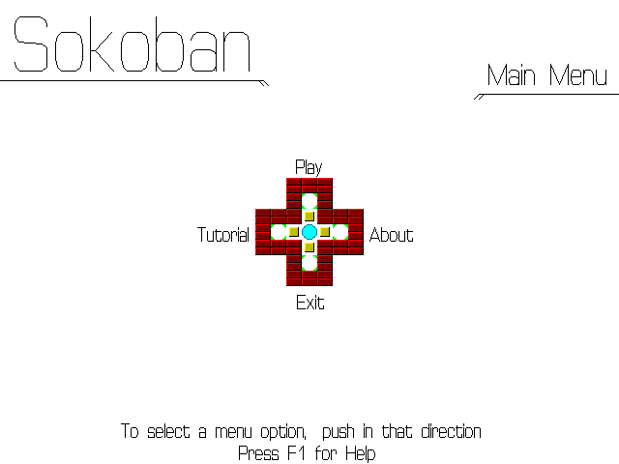

Screenshot 1: Main Menu

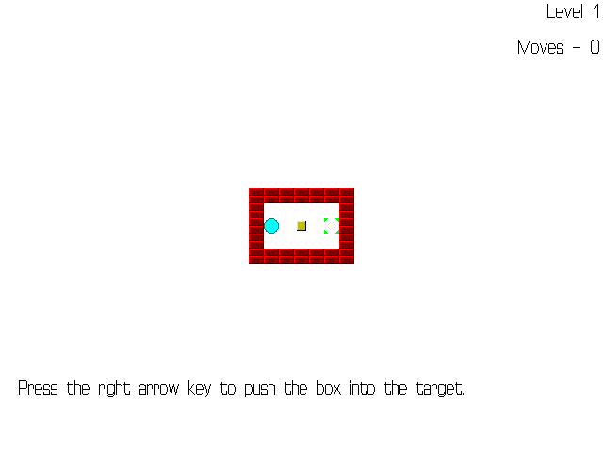

Screenshot 2: Tutorial Level 1

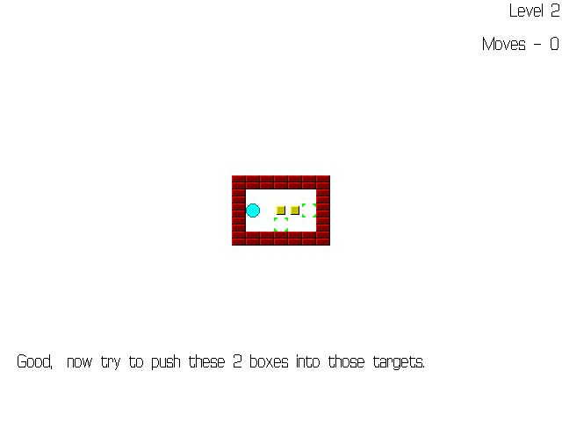

Screenshot 3: Tutorial Level 2

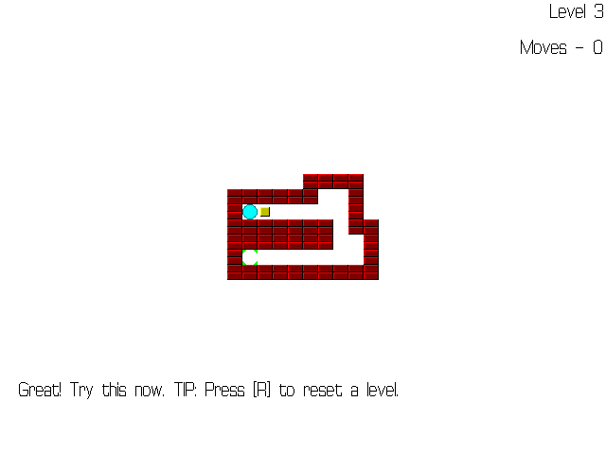

Screenshot 4: Tutorial Level 3

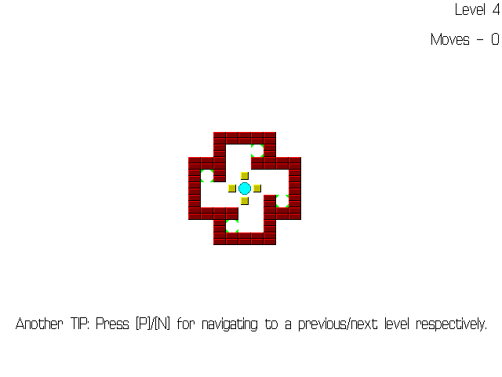

Screenshot 5: Tutorial Level 4

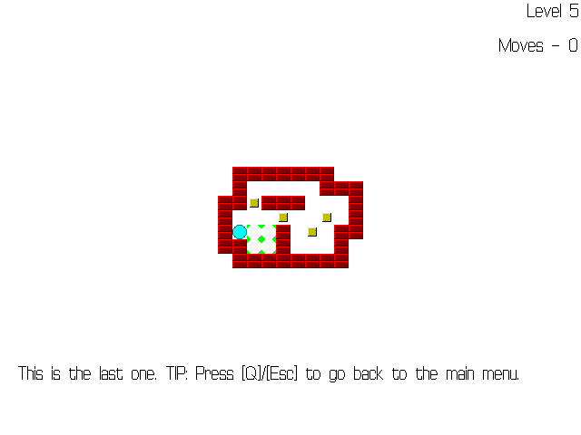

Screenshot 6: Tutorial Level 5

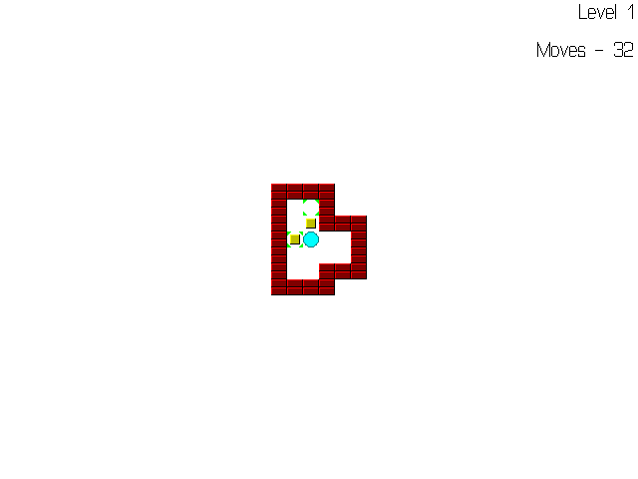

Screenshot 7: Start of Level 1

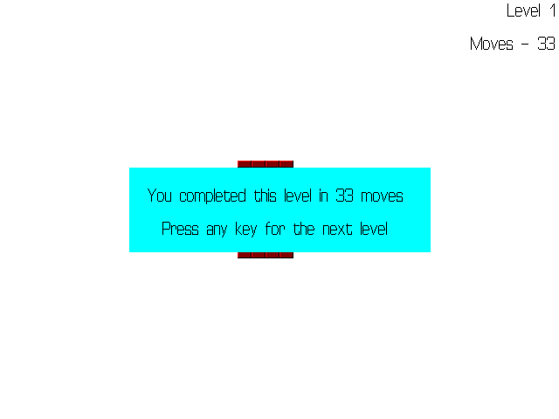

Screenshot 8: End of Level 1



Screenshot 9: Start of Level 155

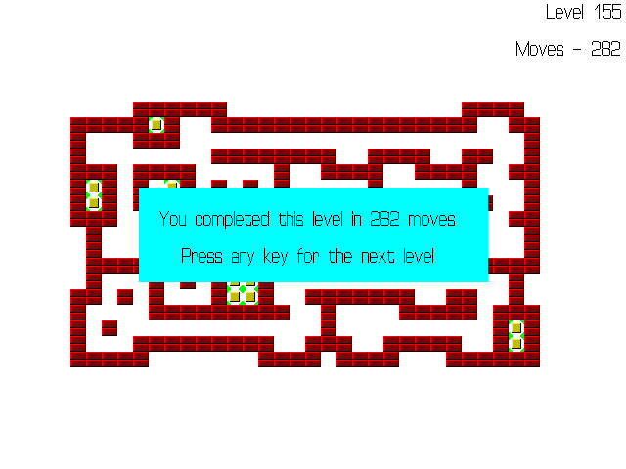

Screenshot 10: End of Level 155

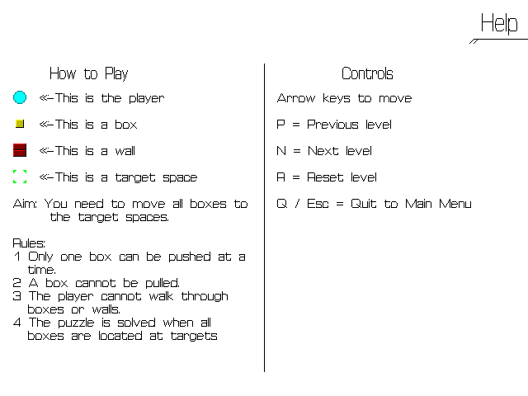

Screenshot 11: F1 Help

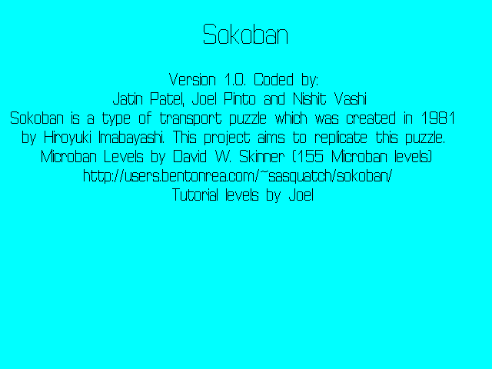

Screenshot 12: About page

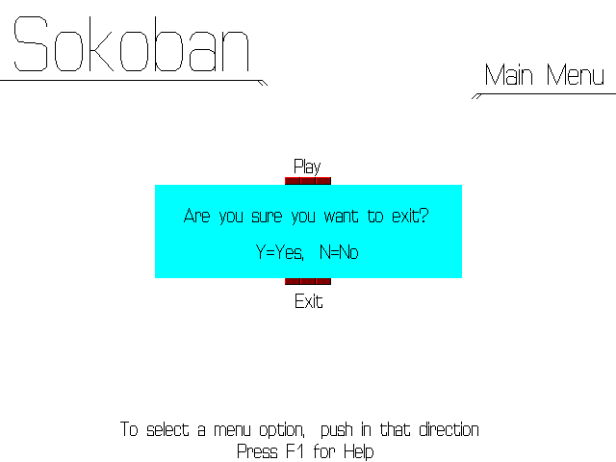

Screenshot 13: Exit confirmation dialog

References

1. David W. Skinner (155 Microban levels)

<http://users.bentonrea.com/~sasquatch/sokoban/>

1. Sokoban - Wikipedia, the free encyclopedia

<http://en.wikipedia.org/wiki/Sokoban>

1. Sokoban Clone

<http://fluxrider.com/projects/sokoban/index.html>

1. Koder’s Code Search: Sokoban.cpp

<http://www.koders.com/cpp/fid079D3C8B44170453FA2A30069DD6477C78D59DCD.aspx>